**Chapter: 12**

1. Here we will learn how to capture input from form element like

* Input tag
* Text area tag
* Select tag

And have data available for form submission

1. **Form elements whose values are controlled by react is called controlled components.**

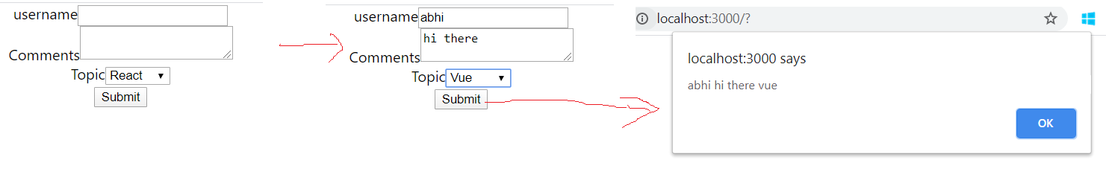

import React, { Component } from "react";

class Form extends Component {

  constructor(props) {

    super(props);

    this.state = {

      username: "",

      comments: "",

      topic: "Angular"

    };

  }

  handelUsernameChange = event => {

    this.setState({

      username: event.target.value

    });

  };

  handelCommentsChange = event => {

    this.setState({

      comments: event.target.value

    });

  };

  handleTopicChange = event1 => {

    this.setState({

      topic: event1.target.value

    });

  };

  handleSubmit = event => {

    alert(`${this.state.username} ${this.state.comments} ${this.state.topic}`);

    event.preventDefault();

  };

  render() {

    return (

      <form onSubmit={this.handleSubmit}>

        <div>

          <label>username</label>

          <input

            type="text"

            value={this.state.username}

            onChange={this.handelUsernameChange}

          />

        </div>

        <div>

          <label>Comments</label>

          <textarea

            value={this.state.comments}

            onChange={this.handelCommentsChange}

          ></textarea>

        </div>

        <div>

          <label>Topic</label>

          <select value={this.state.topic} onChange={this.handleTopicChange}>

            <option value="react">React</option>

            <option value="angular ">Angular</option>

            <option value="vue">Vue</option>

          </select>

        </div>

        <button type="submit">Submit</button>

      </form>

    );

  }

}

export default Form;